What is Energy star portfolio manager?

Energy star portfolio Manager is a web-based benchmarking tool developed by the U.S Environmental Protection agency that allows us to benchmark the energy performance of buildings.

What is benchmarking?

1. To measure and compare a building’s energy to similar buildings by using past consumption.
2. With over 450,000 commercial buildings benchmarked.
3. The web-based informs building owners about their building’s performance.

Energy star portfolio manager tools helps users measure and track the energy use, water use, and greenhouse gas emissions of buildings, all in a secure online environment.

How does this online environment work?

We can enter energy consumption data into portfolio manager manually via Excel spreadsheet or via webservices.

Things that can be done in management tool:

1. Access whole building energy, water, and waste consumption.
2. Share and report data with others.
3. Track changes in energy, water, greenhouse gas emissions, and cost over the time.
4. Create custom reports.
5. Apply for energy star certification.

What type of building types are eligible for energy star?

Banks, stores (supermarkets, retails, wholesale shops), data centers, hospitals, hotels, schools, multifamily housing etc.…

What is the energy star score?

1. The energy star score is calculated based on how efficiently the buildings use energy relative to similar buildings nationwide.
2. The scoring system’s scale from 1 to 100.
3. If the Energy star score is 75 or higher then can apply for Energy star certification.

Who is asking for this data and why?

Any building owners or property managers asking for the data.

Why would they ask for this data?

Validation: Energy star scores provide a way for an organization to validate its Energy star-related efforts.

Peer comparison: Energy star scores let organizations and their investors compare one company against another.

Managing progress: An organization can manage and measure the progress.

Investor attraction: An Energy star score provides investors with an attribute that can help them make ethical, sustainable investing decisions.

Risk management: An Energy star score can help identify areas of potential concern and risk from an ESG perspective.

1. Which building owner has the best Energy star score and why is this important?

FOODLIONCORP has the best Energy Star Score which is very important in order for it stand out from competitors. Similarly, Target, Kohl’s, JCPenney, and Staples are also doing good compared to its competitors.

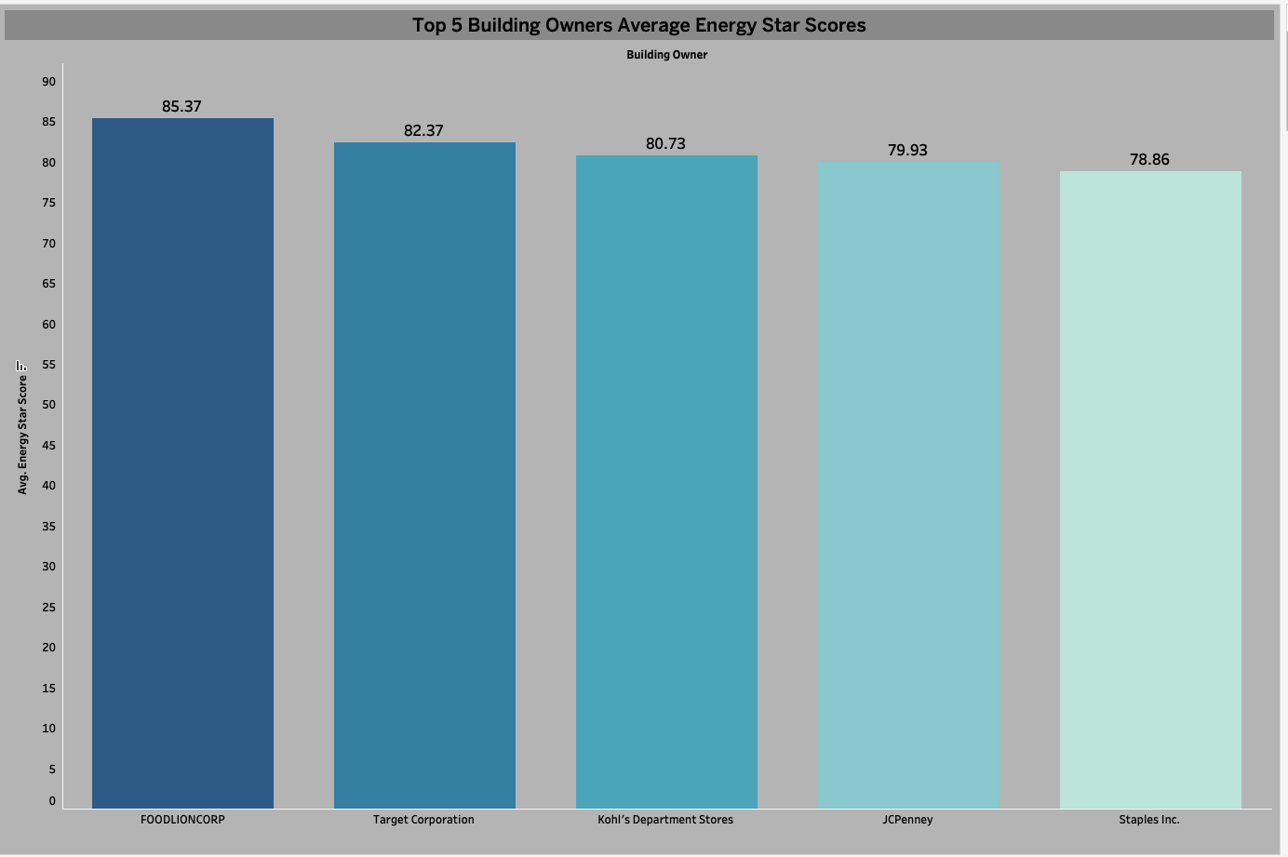

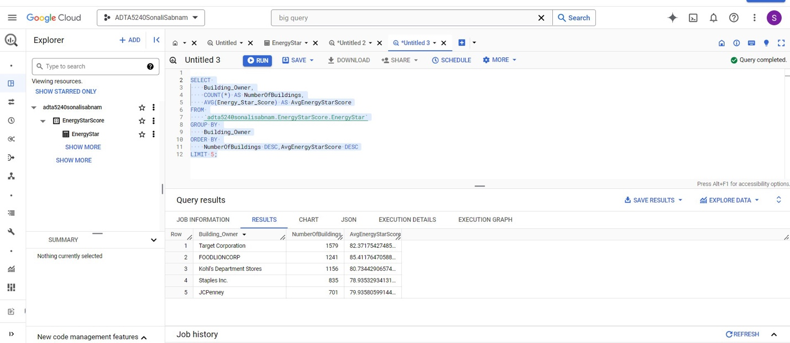

1. Why should property managers care about their Energy star score? Or why would they want to be in Top 5?

Because these scores go to the public and influence their public image greatly. So, if a company is greatly improving their score and are highly rated, it could cause the business to get more customers. It shows that they care about their environmental effects and manage themselves well. Data also says that the top 5 well maintained buildings are stores in order to attract more customers.

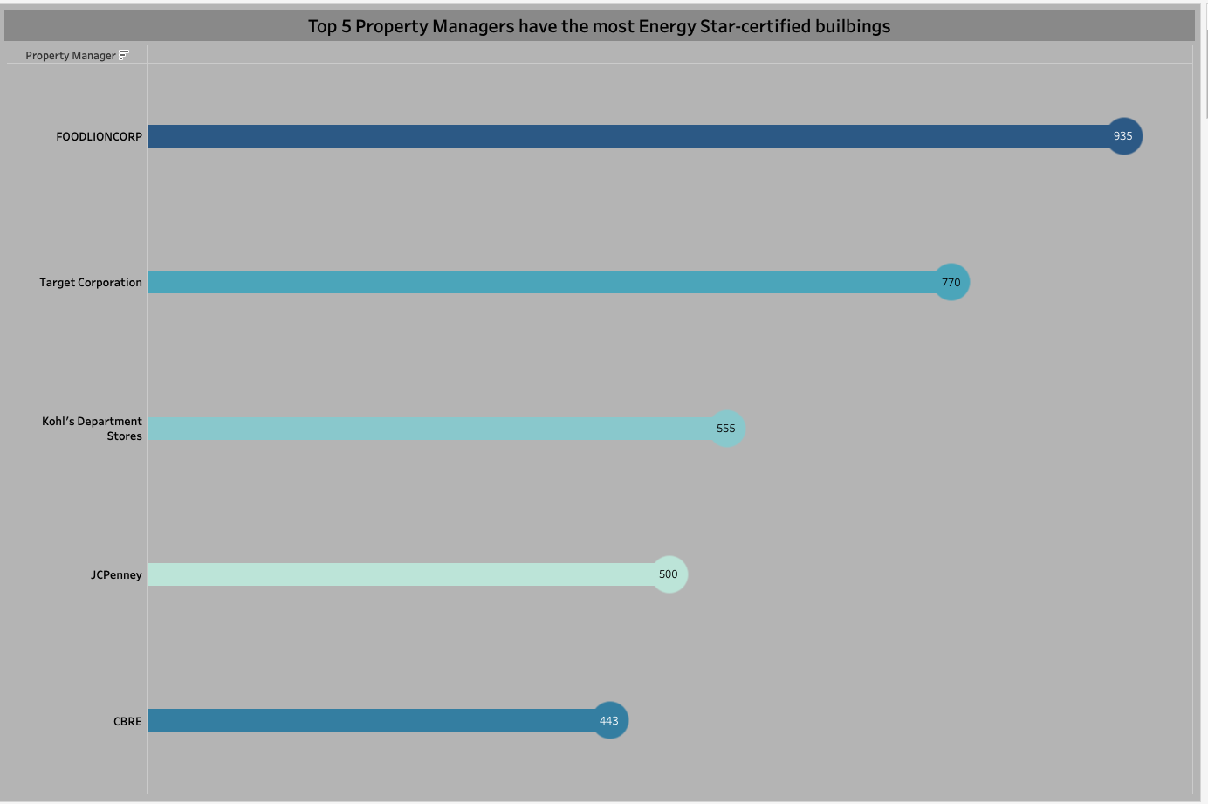

1. Why would the building owner want to know which state and city have the best energy star score?

If they want to start a new business in a new state or city this data will help them choose which state or city is best for starting new buildings.

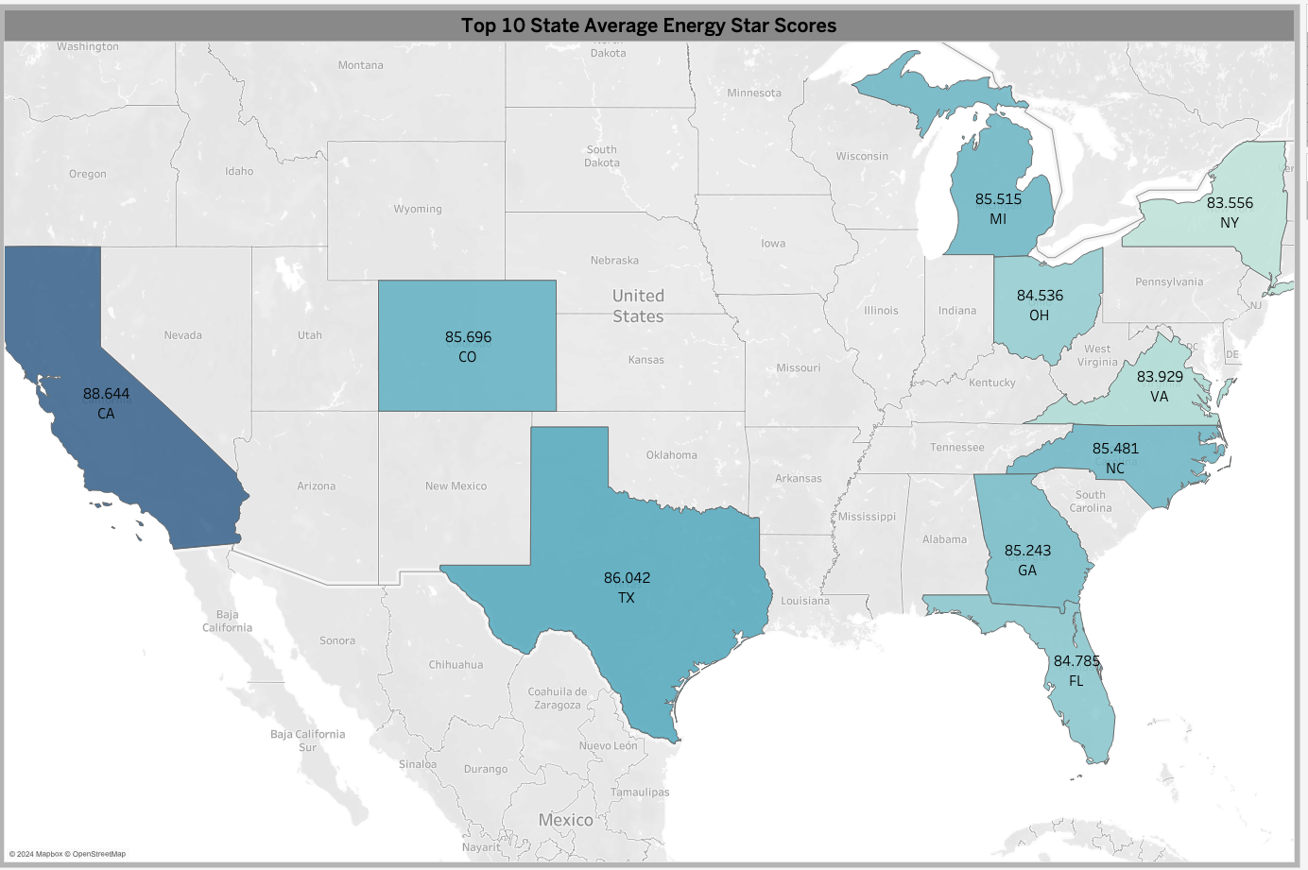

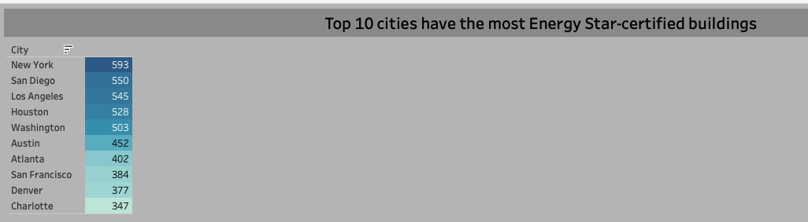

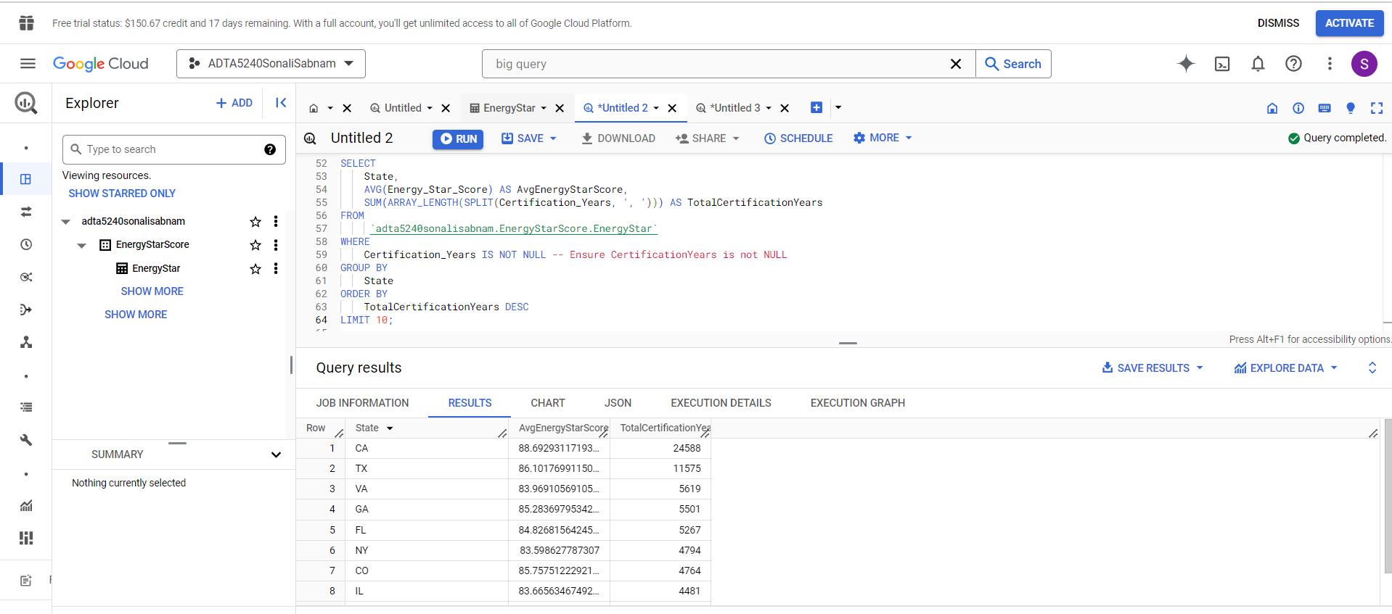

1. Why would the building owners want to know which property types have the best energy star certified buildings?

So, that they can come to a conclusion of which property type is easy to manage. For example, offices, retail stores, and multifamily housing buildings are easier to manage when compared to other commercial buildings. 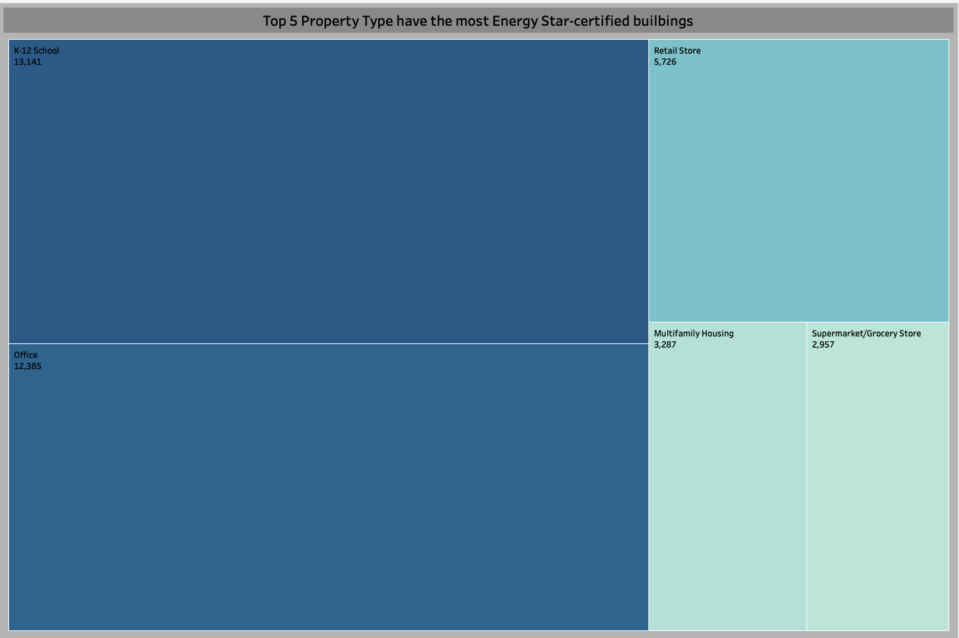

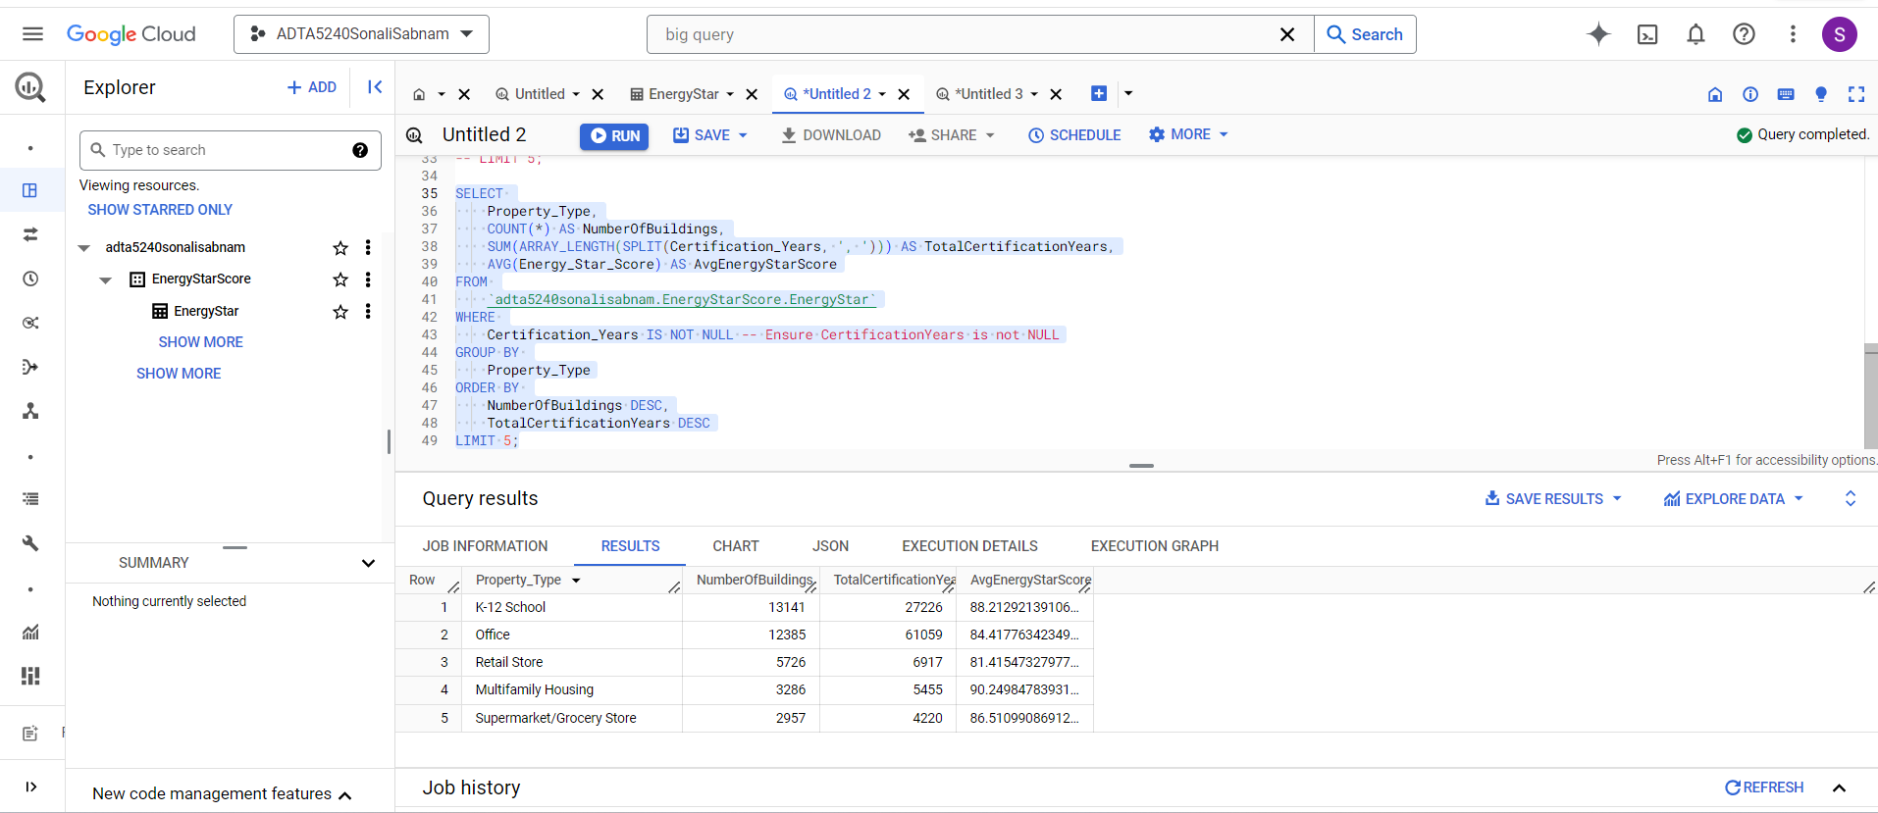

1. Why would the property managers want to know which property types have the highest average energy star scores?

Energy star certified buildings are more attractive to renters due to their lower operating costs and higher performance standards. So, it is best to invest on these property types.

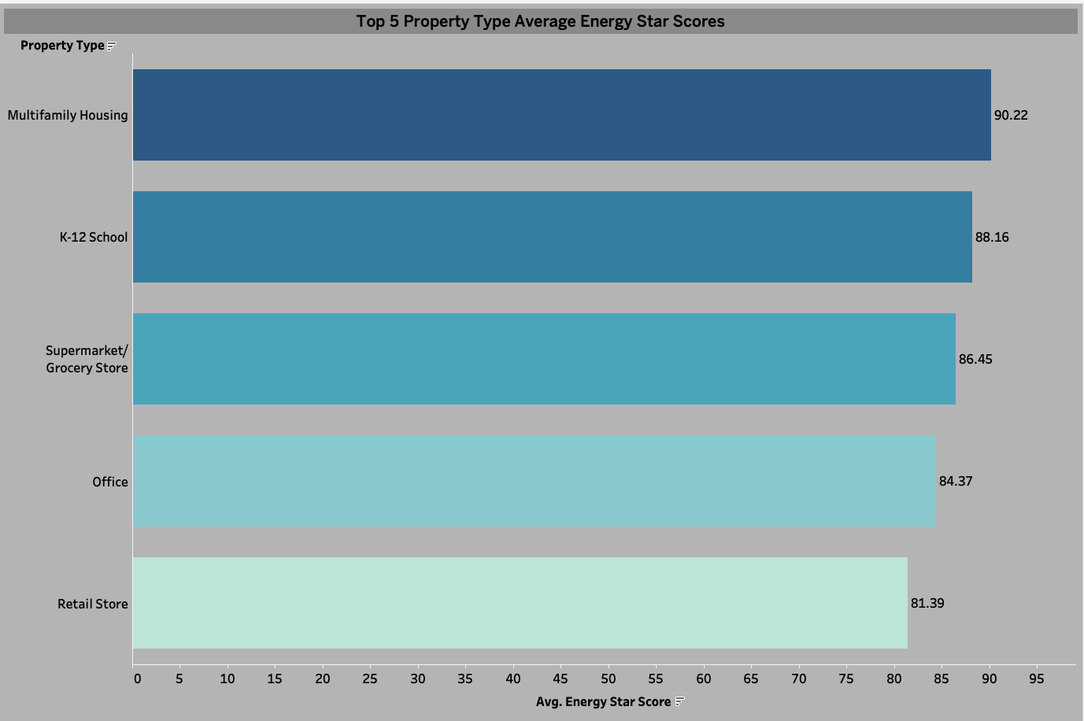

It is important for energy star scores to be public due to a variety of reasons from both a government standpoint and a business standpoint. It is important to have this data public because it will allow organizations to have 5 key insights: validation, peer comparison, managing progress, investor/renters’ attraction, and risk management. Not only is it important for organizations to have this data in order to have those 5 key insights it can also help them in a variety of other ways. Some of which being how a large corporation such as FOODLIONCORP can use the data of its competitors in order to stay ahead of the curve, this also highlights the other side of the story of how a smaller corporation can use the data of more successful corporations in order to emulate their standards and boost their own scores and business. This data can also be important because it will help businesses specifically pinpoint exactly where they should base their businesses and what they need to do with those businesses in order to make it successful, and all of this is only possible because the data of these energy star scores are made public.